**University of Science and Technology of Hanoi**

**Group Project Report**

**Subject: Data analysis and Visualization**

**Period: 2020-2021**

**Object:**

**Practical on analyzing and visualizing gamma-emitting detected by scintillation Isotope Am-241**

**Department:** **Space and Application**

|  |  |
| --- | --- |
|  | **Members:**   * **Nguyen Tuan Ngoc - BI 10-126** * **Tran Thi Hien Mai - BI 10-109** |

***Lecturer:***

* **Phan Thanh Hien**
* **Hoang Duc Thuong**

**Hanoi, June 2021**

Table of contents

I. Abstract 3

II. Report 3

a) Introduction 3

b) Process 4

c) Possible future projections and recommendations 5

III) Final results and Conclusion: 6

IV) References 8

**Table of Figures**

Figure 1 I trying to figure difference between two files 4

Figure 2 After changing .sim to .txt 5

Figure 3. Am241, 55V input voltage, High Gain Figure 4. Am241, 55V input voltage, Low Gain 9

Figure 5 Fitting with Gaussian fitting 10

# I. **Abstract**

By detecting gamma ray, the observer can know whether the violent events, such as chemical elements created, stars exploding, matter falling in black holes and celestial object colliding, happen (1). But the gamma ray is the highest intensity ray and the most penetrating comparing to another electromagnetic waves. Secondly, they are quite fewer than the others (2). Consequently, it can be said that it is really hard to “catch” an individual gamma ray. The only available way now is detecting them by tracing back to Gamma-ray events (3): Compton scattering, Photoelectric absorption, Pair production, likewise the effects of light through material.

In our lecture, we were taught about the mechanism, process and structure of the scintillation, two types of it: organic and inorganic, and finally is way to analyze the gamma ray data.

The goal of our practical is to get used with analyzing the data about gamma ray collected from scintillation isotope Am-241 and visualizing that data on the graph.

To be most efficient and use of time the most, we chose to code and write report at the same time and then combine the results instead of dividing two part and two phases.

# II. **Report**

1. Introduction:

In this practical, we need to use python language to take the data from the file and analyze and plot it on the graph. We chose Google Colab because it helps us to code together online and its space also speed is quite high.

Overall, there are 5 steps in our process: Prepare necessary libraries and files path, read the file, get data, define fit range then plot it on the graph and fit it with the Gaussian fitting function.

1. Process:

In the first step, individually, I found that if it is a small or single project, it would be less complicated to direct the path for the folder rather than building a structure of path.

In the second step, we got trouble with reading .sim file, and after replacing .sim by .txt, we can normally read the file. I found that the .sim file and the .txt led to the same result on plotting (comparing to the result of .sim file of lecturer Phan Thanh Hien), and .sim file is only different if we want to use it to stimulate, such as in MATLAB.

And, if we write the data in the library class-like structure with [key] and [value], it would be easier to read and manage the data.

Also, I found that defining limit time and step limitation for the running code, dividing code in smaller block/part are essential because they prevent the terminal from being broken or shut down.

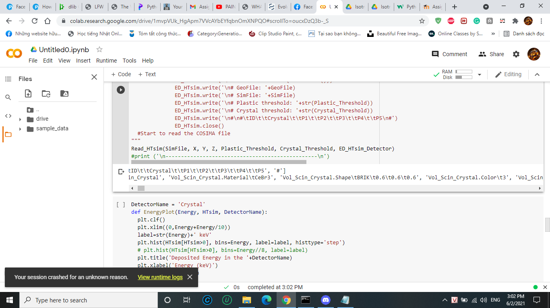

Figure 1 I trying to figure difference between two files

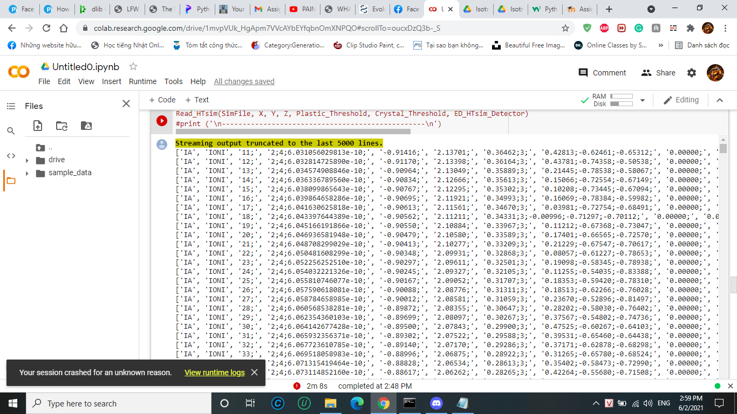

Figure 2 After changing .sim to .txt

1. Possible future projections and recommendations:

Our aim in the future is to try to analyze another type of scintillation’s material to see if we have the same results and if there are differences between them so we can compare to know which is the best material and reason that made those differences.

We also want to manipulate to optimize the code to minimum space disk and resources required.

# III) Final results and Conclusion:

1. **Simulation Data:**

* Running ‘SimulationData.ipynb’ to get Deposited Energy Spectra for every simulation.

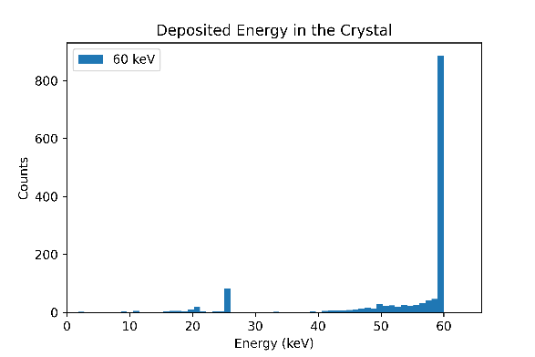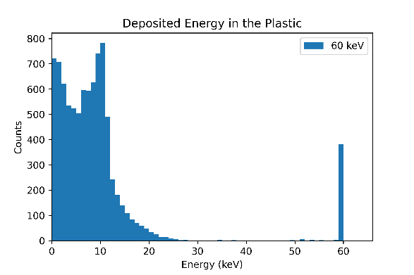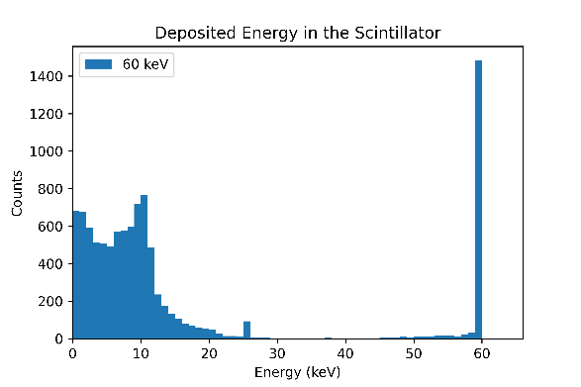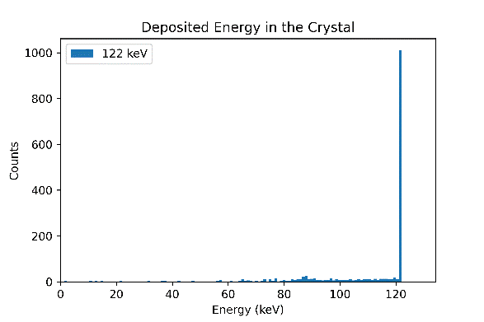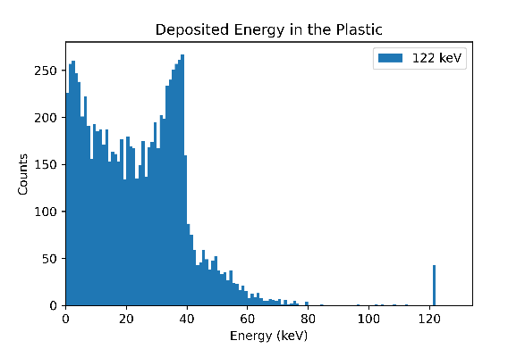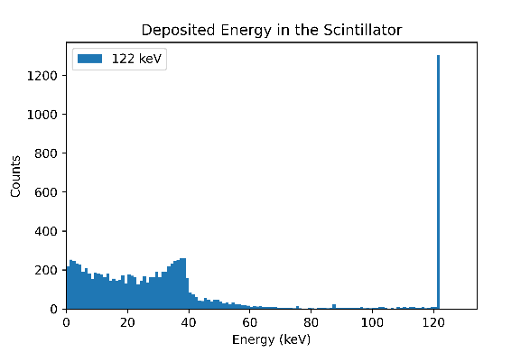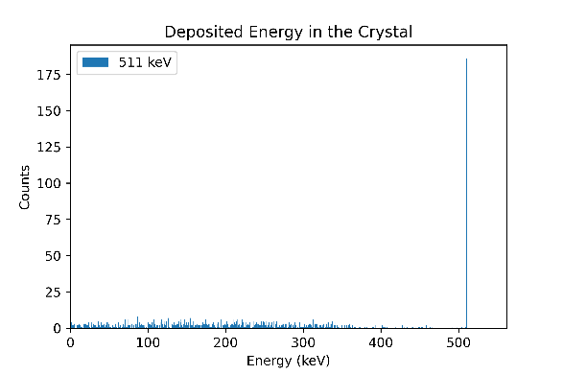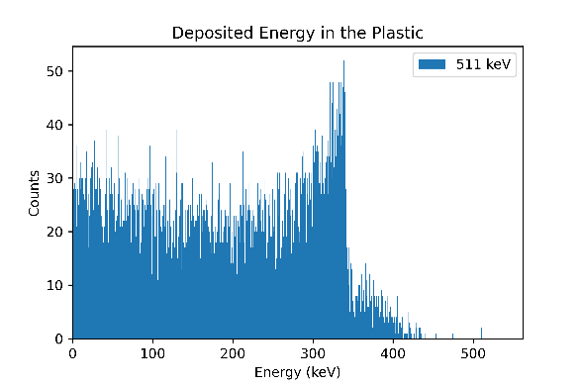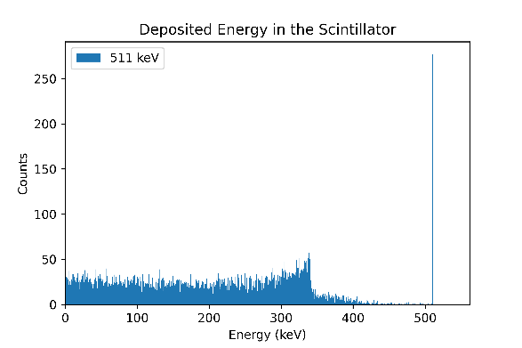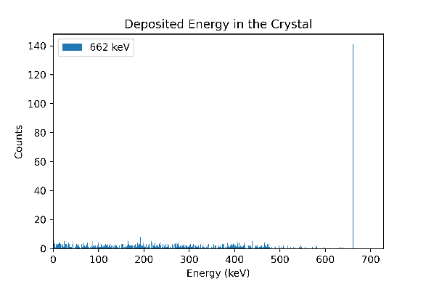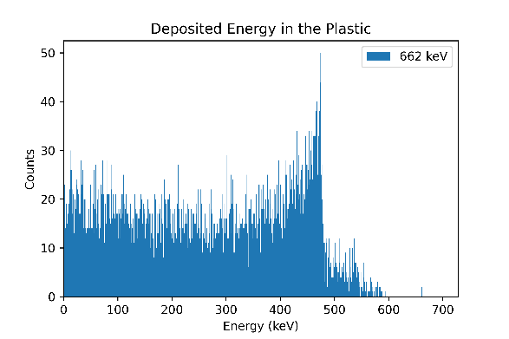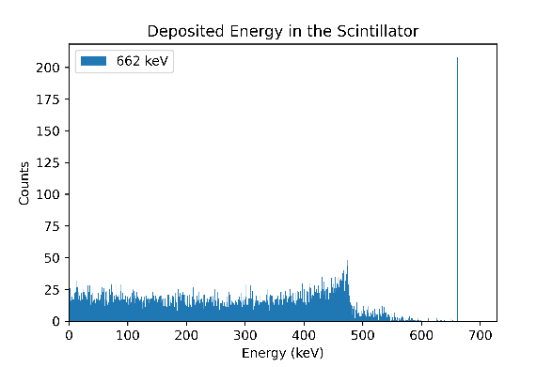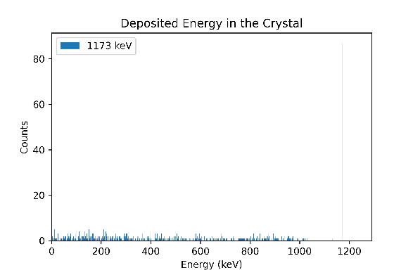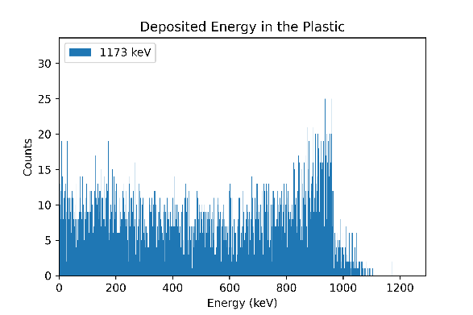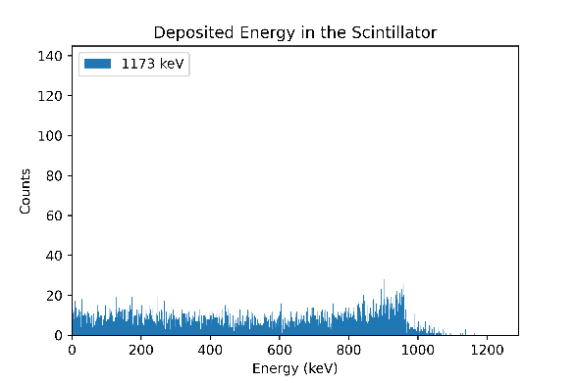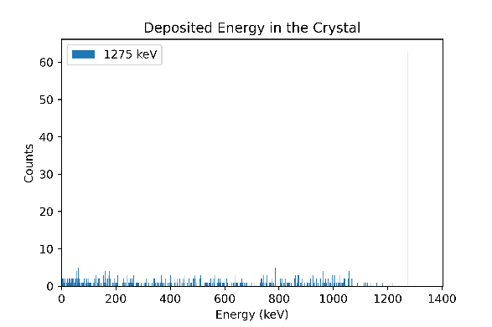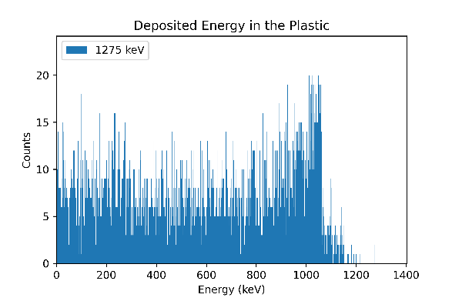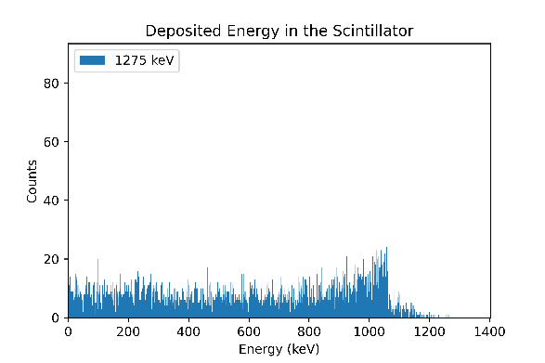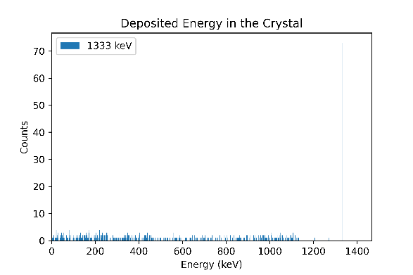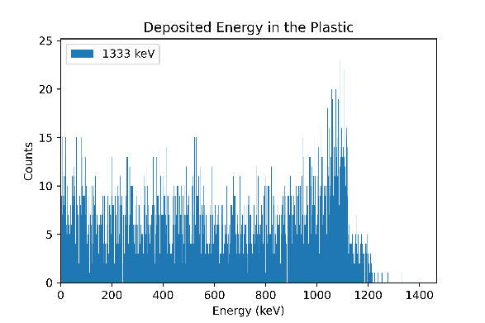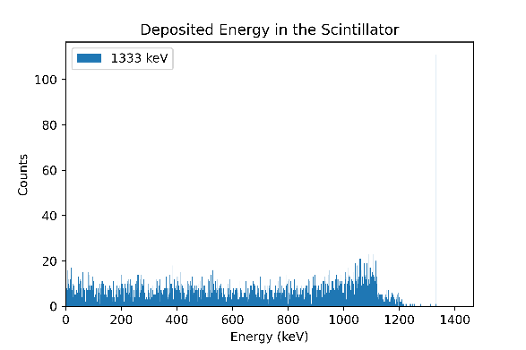

In simulation, the peak of detection stays in a single energy bin in the histogram. Gamma-ray photons is expected to deposit energy at one specific energy level.

1. **Measurement Data:**

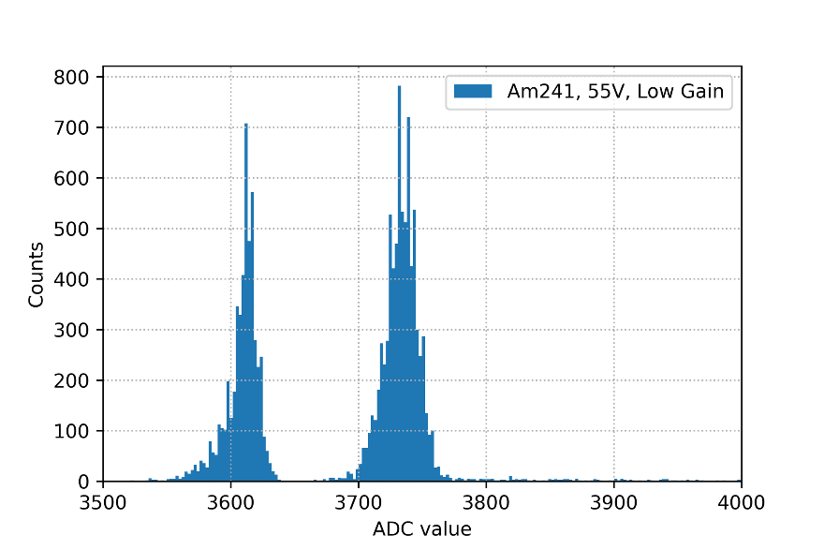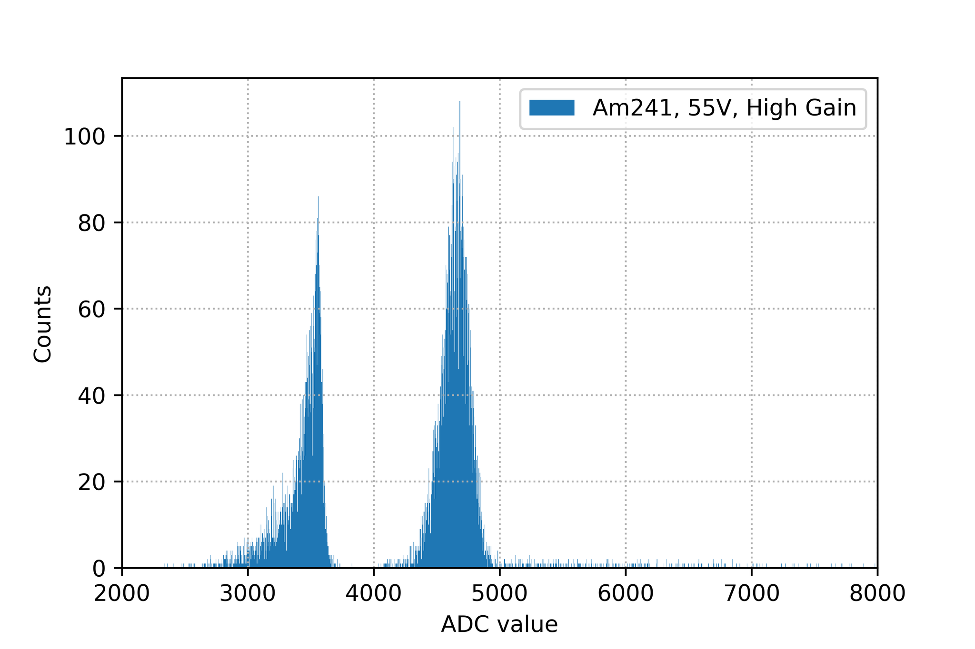

Figure 3. Am241, 55V input voltage, High Gain Figure 4. Am241, 55V input voltage, Low Gain

The detector used for measuring is CeBr3 crystal scintillator. Radioactive source is 241Am.

Input voltage: 55V.

The EASIROC board has 32 channels, we only work on **channels 5,6,9,10.**

The folder “Measure_Am241_55V” has totally 52,666 .lvm files.

There are 26329 files containing no data, having ‘._ADC’ in filenames.

There remain 26337 ADC files.

- There are 13161 High Gain files.

- There are 13176 Low Gain files.

For each file, we sum the ADC values of 4 channels 5,6,9,10 and create histograms based on these sums.

Also, we only focus on a specific range for each histogram: [2000,8000] for HG and [3500,4000] for LG.

From the two histograms, we can find the peak ADC counts at **108 (for HG) and 782 (for LG)**.

Each peak of a histogram can be considered as a Gaussian distribution. Gaussian lines are often above a Compton continuum.

- We model a model to make the histogram fit both a Gaussian distribution and a linear function with a specific fit range for each: (4200,5500) for HG and (3690,3770) for LG.

- Fitting function:

We could find the parameters of this function for each case as shown.

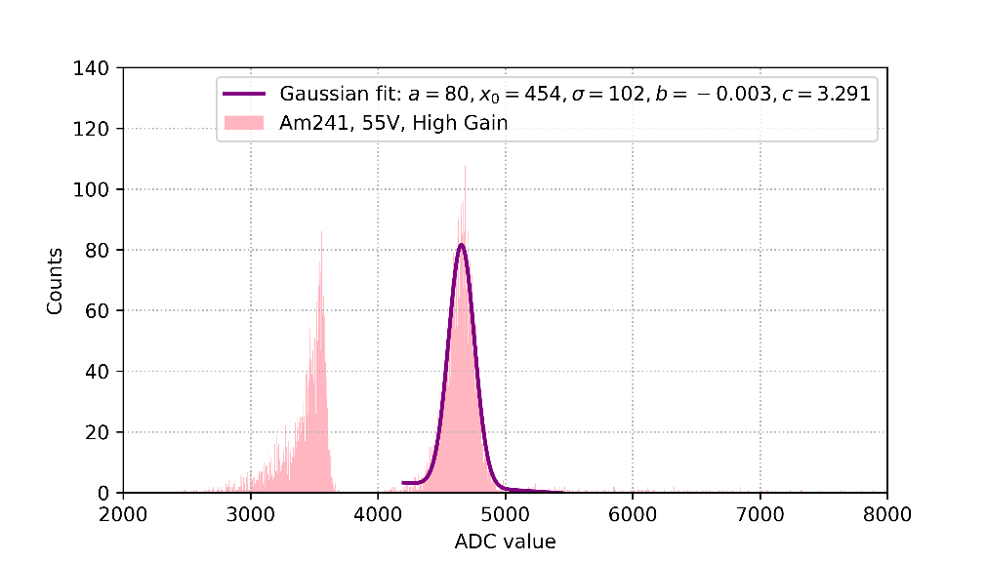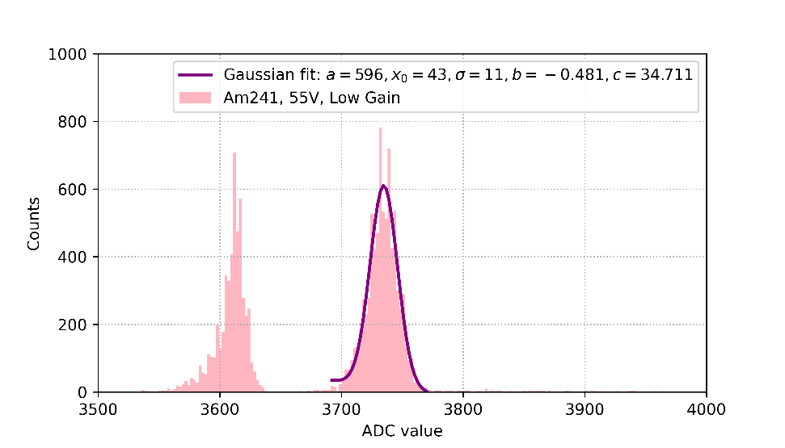

Figure 5 Fitting with Gaussian fitting

**fit range:** (4200,5500) (3690,3770)

After the practical, we learnt how to define the functions, got used with analyzing and visualizing the data.

# IV) References

1. Why do we observe gamma rays, link: <http://www.esa.int/Science_Exploration/Space_Science/Integral/Why_do_we_observe_gamma_rays>
2. How do scientists "see" gamma rays, link: <https://imagine.gsfc.nasa.gov/science/toolbox/observations.html>
3. Lecture 01: Gamma-ray in nature and the photon counting system, Dr. Phan Thanh Hien, link: <https://drive.google.com/drive/u/2/folders/1QoocUNQ4hSSzV5WmoqctCvNV6kGB2f4y>